DOCKER – TASK -03
==================================================================================

Create a image from running container.
downloaded the latest Nginx image from Docker Hub.
- docker pull nginx:latest

created and started a container using the Nginx image and mapped port 81 → 80.
- docker container run -itd -p 81:80 --name nginx-container nginx:latest

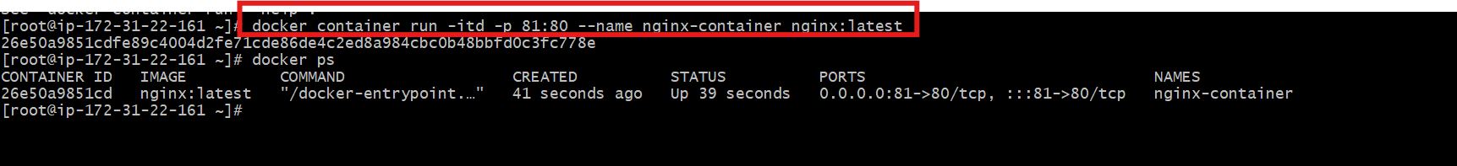
checked that the container is running.
- docker ps
accessed the container terminal.
- docker exec -it nginx-container /bin/bash
Inside the container, you changed the default Nginx page.
- echo "CONTAINER CREATED FROM RUNNING NGINX IMAGE" >> /usr/share/nginx/html/index.html
saved the current state of the container as a new image.
- docker commit nginx-container custom-nginx:v1

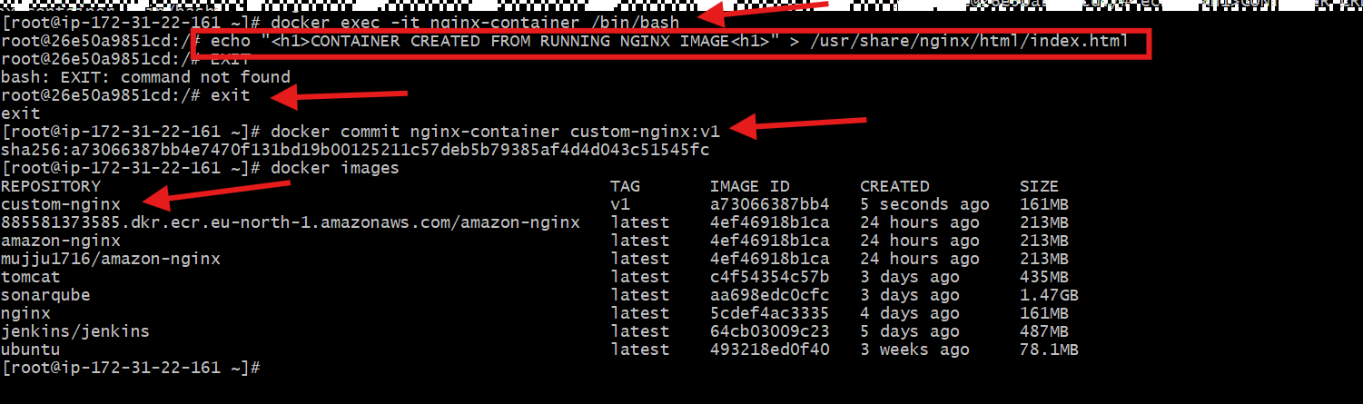

opened the server IP with port 81:
http://<EC2-IP>:81
CONTAINER CREATED FROM RUNNING NGINX IMAGE

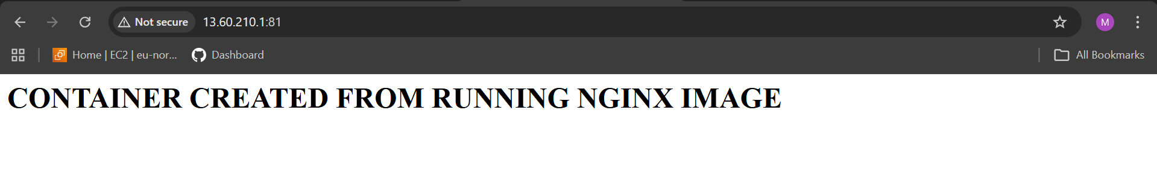

Copy image from local machine to docker server and load the image.
authenticated with Docker Hub.
- docker login
downloaded the latest Nginx image on your local Windows machine.
- docker pull nginx
checked that the image exists locally.
- docker images
exported the image into a .tar file.
- docker save nginx -o nginx.tar
confirmed that nginx.tar was created.
- ls -lh nginx.tar
copied the file from Windows to EC2.
- scp -i linux.pem nginx.tar ec2-user@13.60.210.181:/tmp/

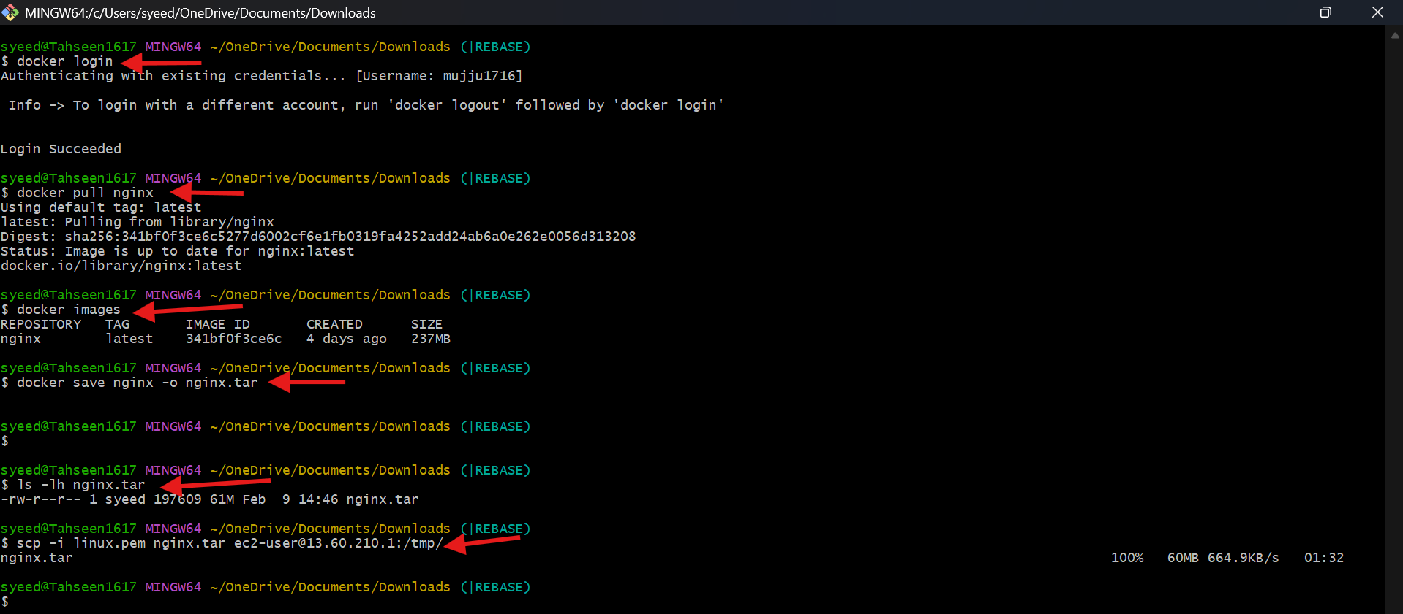

Inside EC2, moved to /tmp and listed files.
cd /tmp
ls
found:
nginx.tar

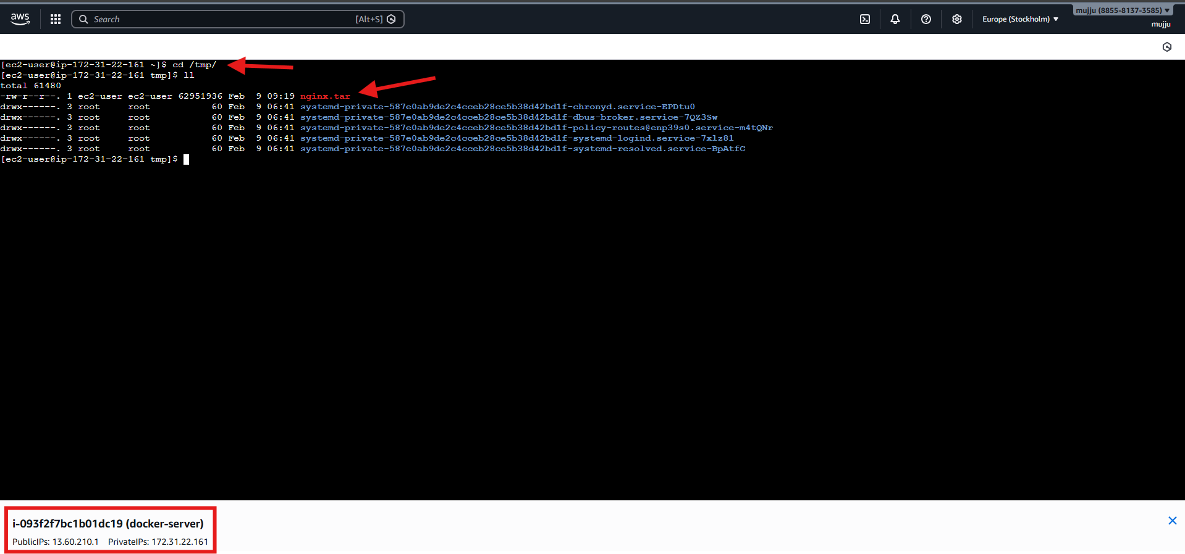

Create Docker image using alpine and customize with tomcat.
created a folder for your Docker build.
- mkdir alpine-tomcat
- cd alpine-tomcat
created and opened a Dockerfile.
- vi Dockerfile
FROM alpine:3.19

# Install Java and required tools
RUN apk add --no-cache openjdk11 wget tar bash

# Set working directory
WORKDIR /opt

# Download and extract Tomcat
RUN wget https://dlcdn.apache.org/tomcat/tomcat-9/v9.0.115/bin/apache-tomcat-9.0.115.tar.gz \
&& tar -xzf apache-tomcat-9.0.115.tar.gz \
&& mv apache-tomcat-9.0.115 tomcat \
&& rm apache-tomcat-9.0.115.tar.gz

# Expose Tomcat port
EXPOSE 8080

# Start Tomcat
CMD ["/opt/tomcat/bin/catalina.sh", "run"]

built the image and named it alpine-tomcat.
- docker build -t alpine-tomcat .
checked available images.
- docker images
saw:
alpine-tomcat latest ~296MB

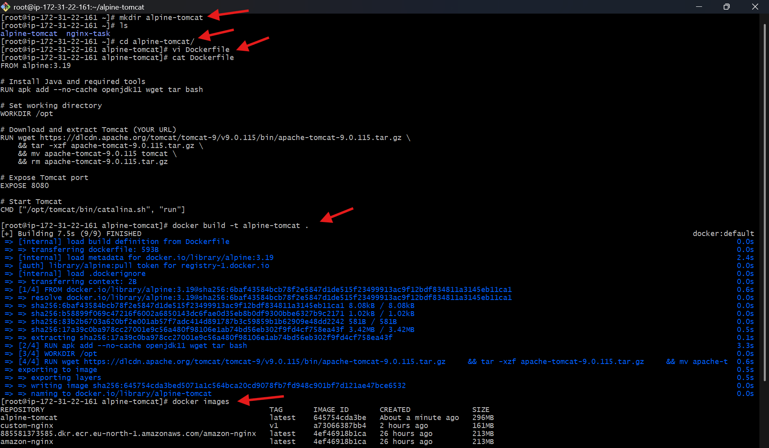
started a container from custom image.
- docker run -d -p 8080:8080 --name tomcat-container alpine-tomcat

opened:
http://13.60.210.181:8080
And saw the Tomcat welcome page.

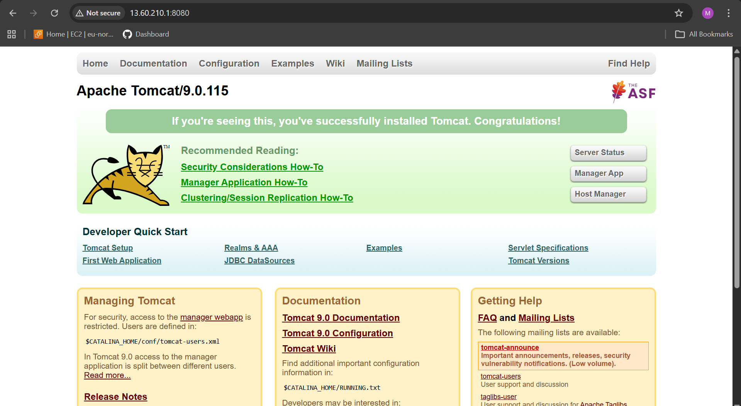

- Create single stage and multi stage docker file using this source code: https://github.com/betawins/multi-stage-example.git
installed Git to download the project source code.
- yum install git -y

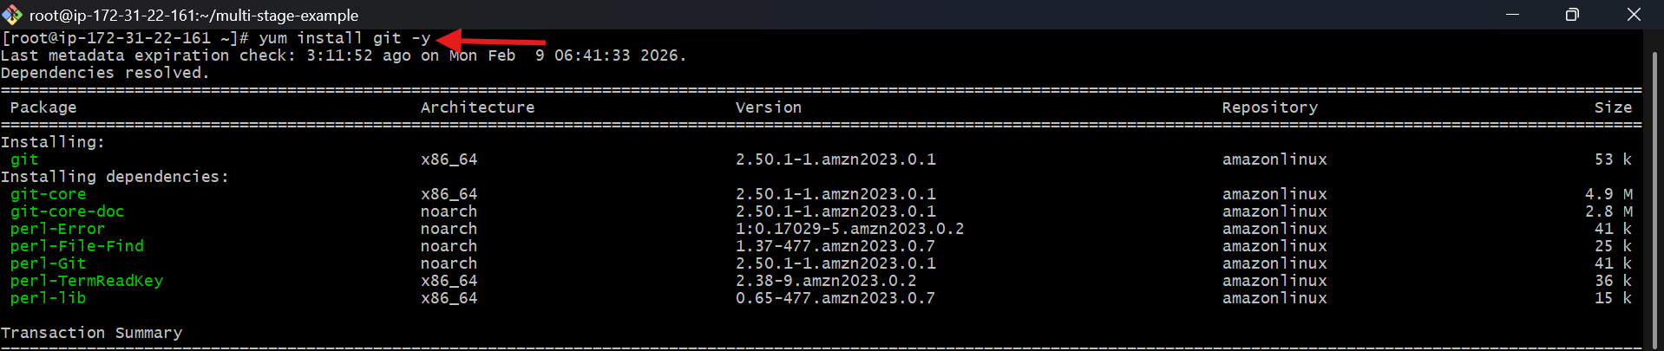
cloned a Maven-based sample project from GitHub.
- git clone https://github.com/betaws/multi-stage-example.git
moved into the cloned folder.
- cd multi-stage-example
Then checked files:
ls
opened and verified the Dockerfile.
- vi Dockerfile
FROM maven:3.9.6-eclipse-temurin-8

WORKDIR /app

COPY . .

RUN mvn clean package -DskipTests

EXPOSE 8080

CMD ["java","-jar","target/multi-stage-example-0.0.1-SNAPSHOT.jar"]

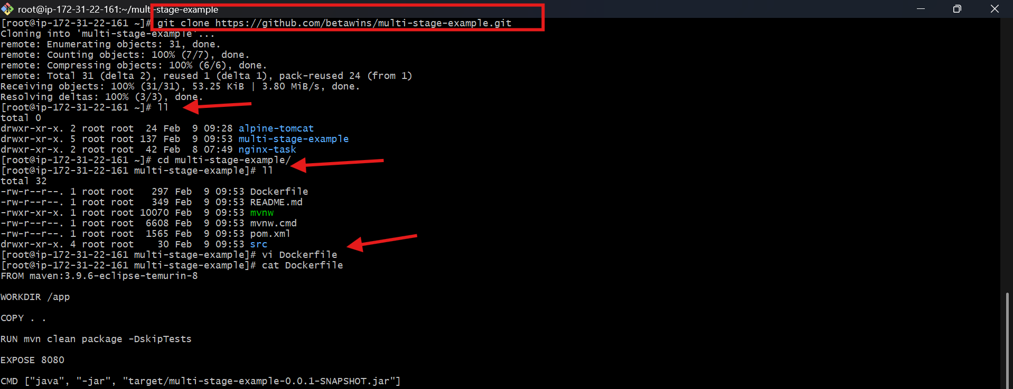
built the Docker image and named it maven-app.
- docker build -t maven-app .
started a container and mapped port 8081 → 8080.
- docker run -d -p 8081:8080 --name myapp maven-app

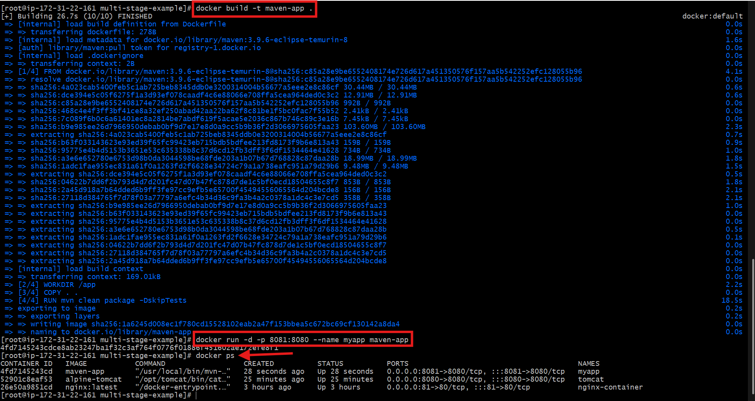
opened:
http://13.60.210.181:8081
You got:
Whitelabel Error Page (404)

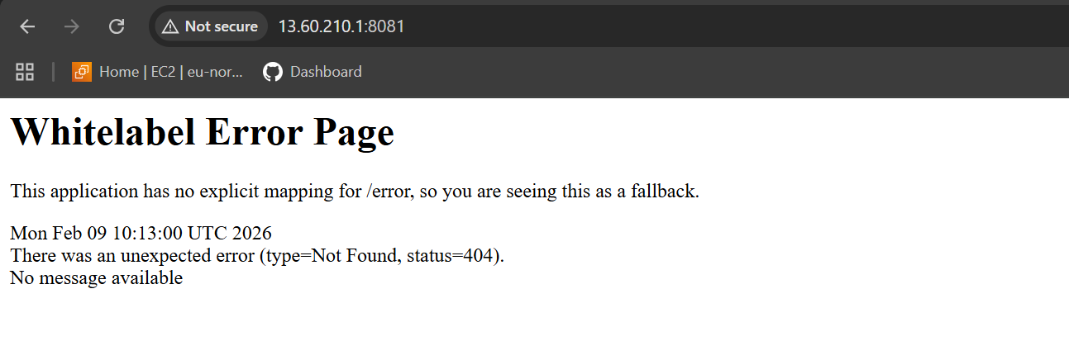
Inside the project directory, you edited the Dockerfile.
vi Dockerfile
# -------- BUILD STAGE --------
FROM maven:3.9.6-eclipse-temurin-8 AS builder

WORKDIR /app

COPY . .

RUN mvn clean package -DskipTests

# -------- RUN STAGE --------
FROM eclipse-temurin:8-jre

WORKDIR /app

COPY --from=builder /app/target/*.jar app.jar

EXPOSE 8080

CMD ["java", "-jar", "app.jar"]
built a new image called multi-stage-app.
docker build -t multi-stage-app .

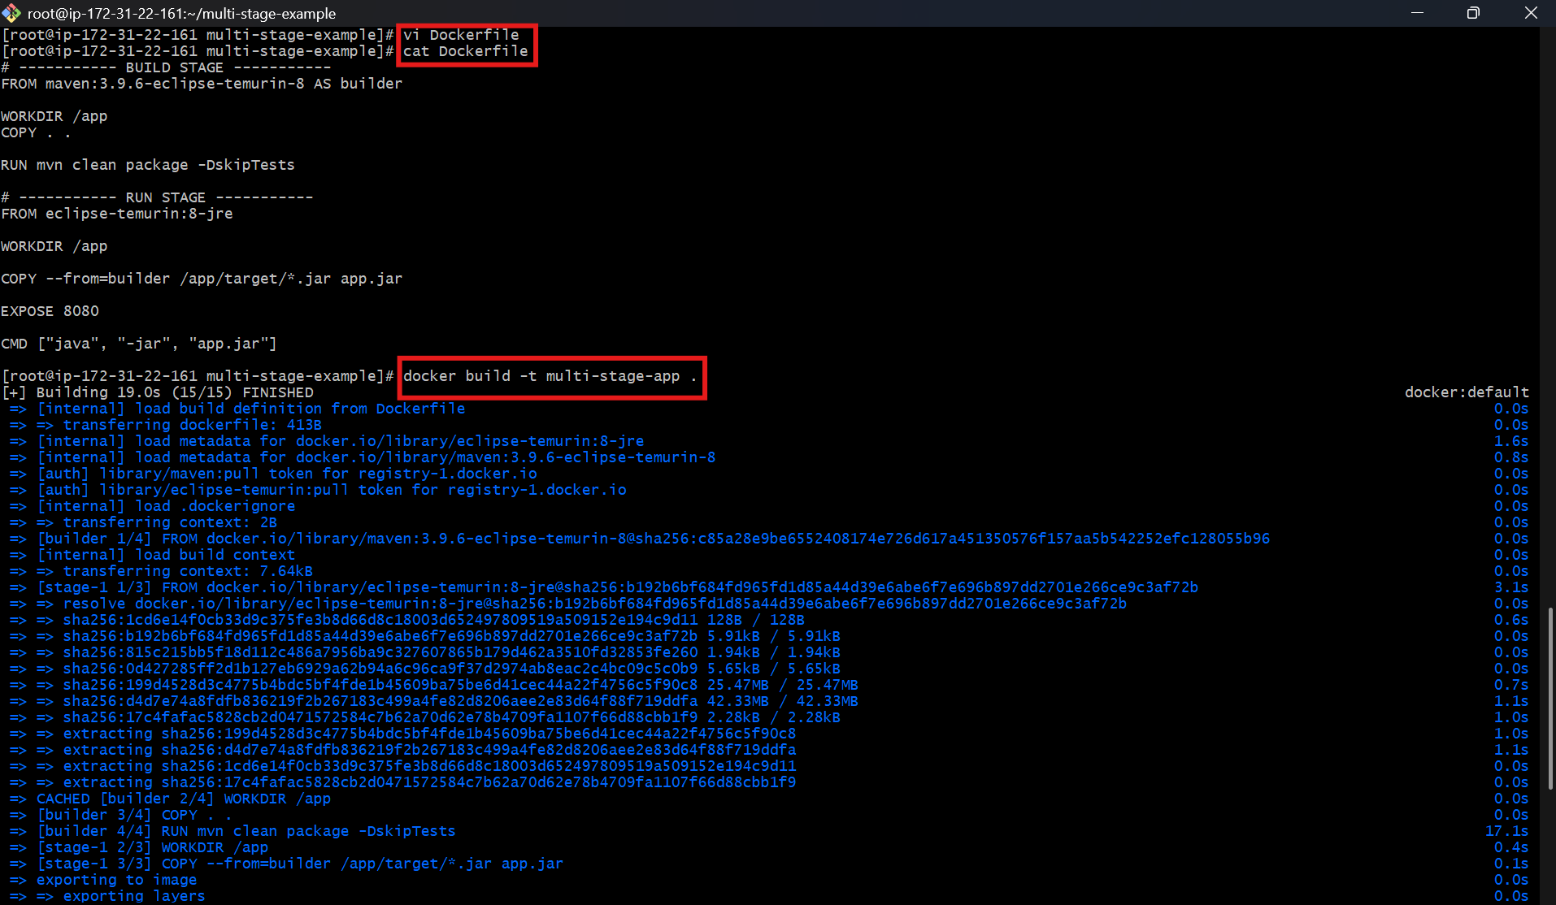
started a new container.
- docker run -d -p 8082:8080 --name myapp2 multi-stage-app

opened:
http://13.60.210.181:8082
And saw:
Whitelabel Error Page (404)
This confirms:

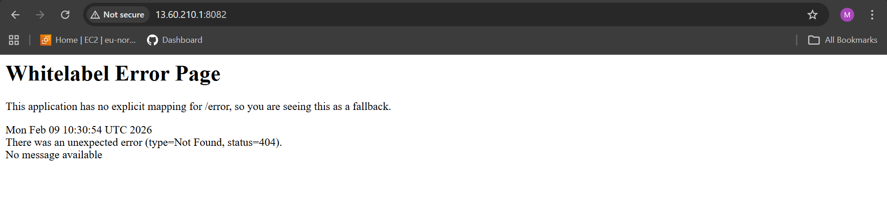

Install docker compose and execute sample application.
downloaded Docker Compose on your EC2 server.
- sudo curl -L https://github.com/docker/compose/releases/latest/download/docker-compose-linux-x86_64 \
-o /usr/local/bin/docker-compose
made the file executable.
- sudo chmod +x /usr/local/bin/docker-compose
created a shortcut link.
- sudo ln -s /usr/local/bin/docker-compose /usr/bin/docker-compose

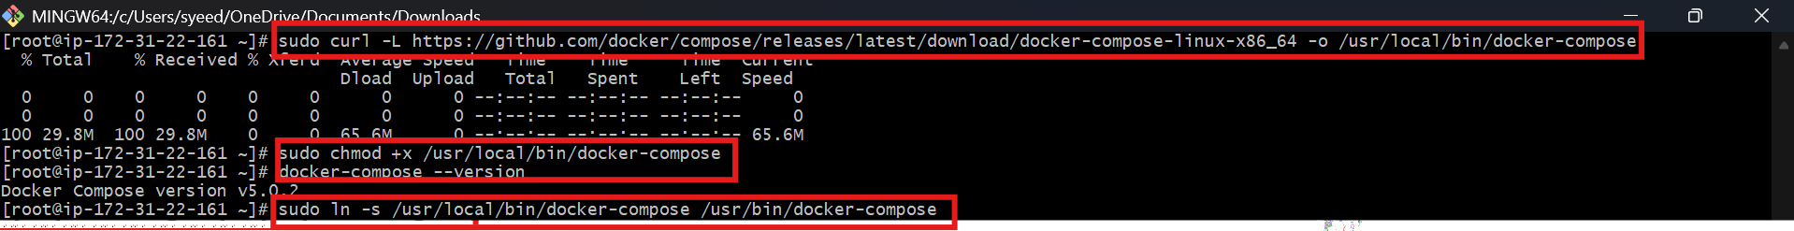
vi docker-compose.yml
version: "3"

services:
web:
image: nginx:latest
ports:
- "8090:80"
started containers in background mode.
- docker-compose up -d
verified service status.
- docker-compose ps

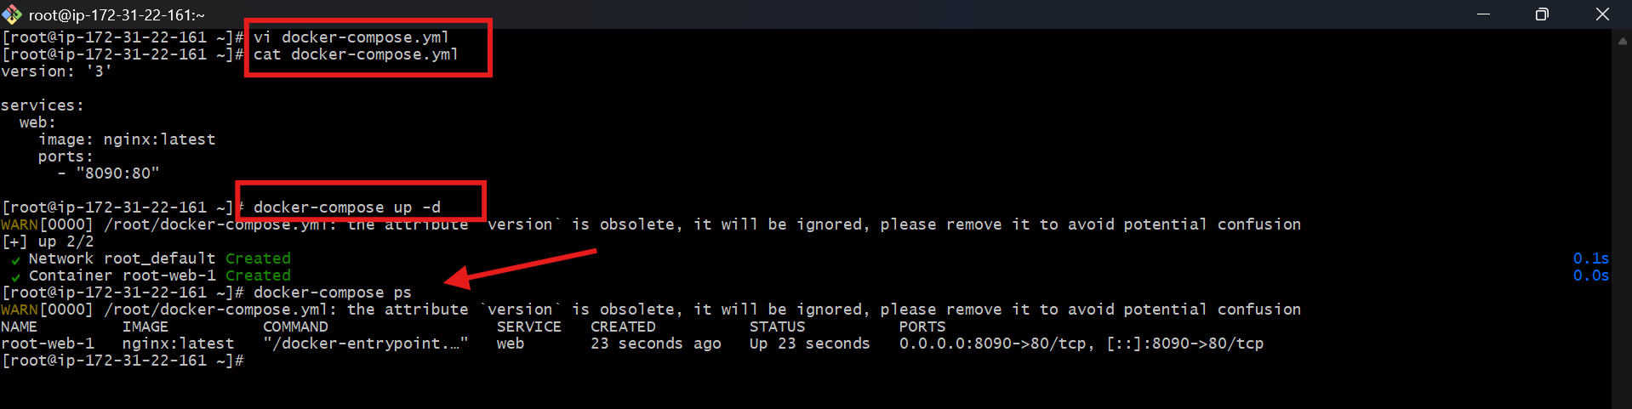
opened:
http://13.60.210.181:8090
And saw the Welcome to nginx page.

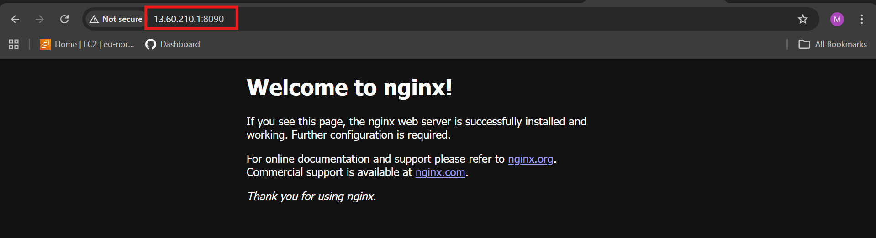

- Implement solution to scan images when pushed to docker registry.
On Docker Hub (repository settings):
- Open your repository: muji1716/amazon-nginx
- Go to Settings
- Under Image security insight settings
- Select Docker Scout image analysis
- Click Save

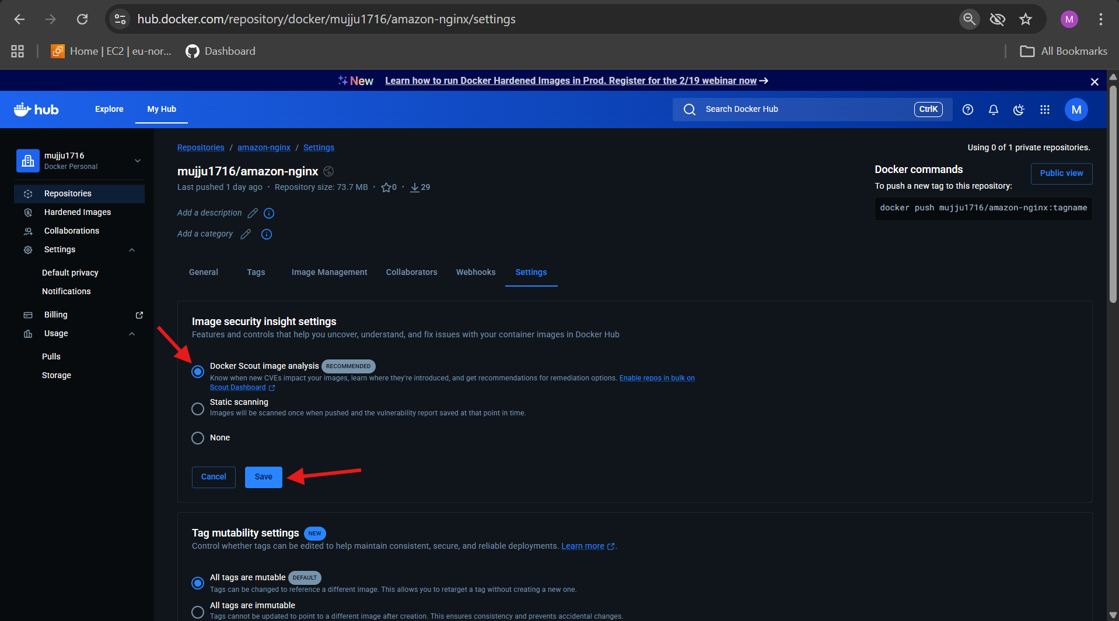
authenticated from your EC2 server.
- docker login

listed all available images.
- docker images
renamed (tagged) your local image to match your Docker Hub repo.
- docker tag multi-stage-app:latest muji1716/amazon-nginx:v1
uploaded the image.
- docker push muji1716/amazon-nginx:v1

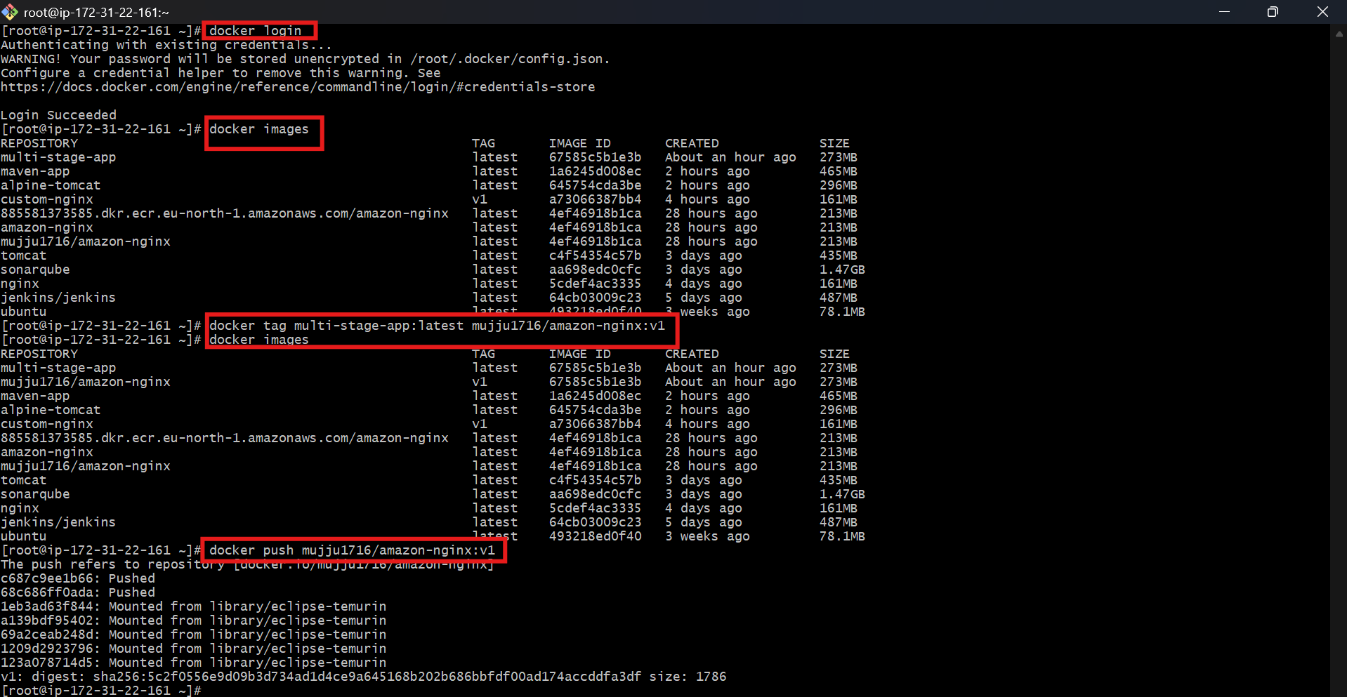
On Docker Hub → Tags section:
saw:
v1
And vulnerability scan results.

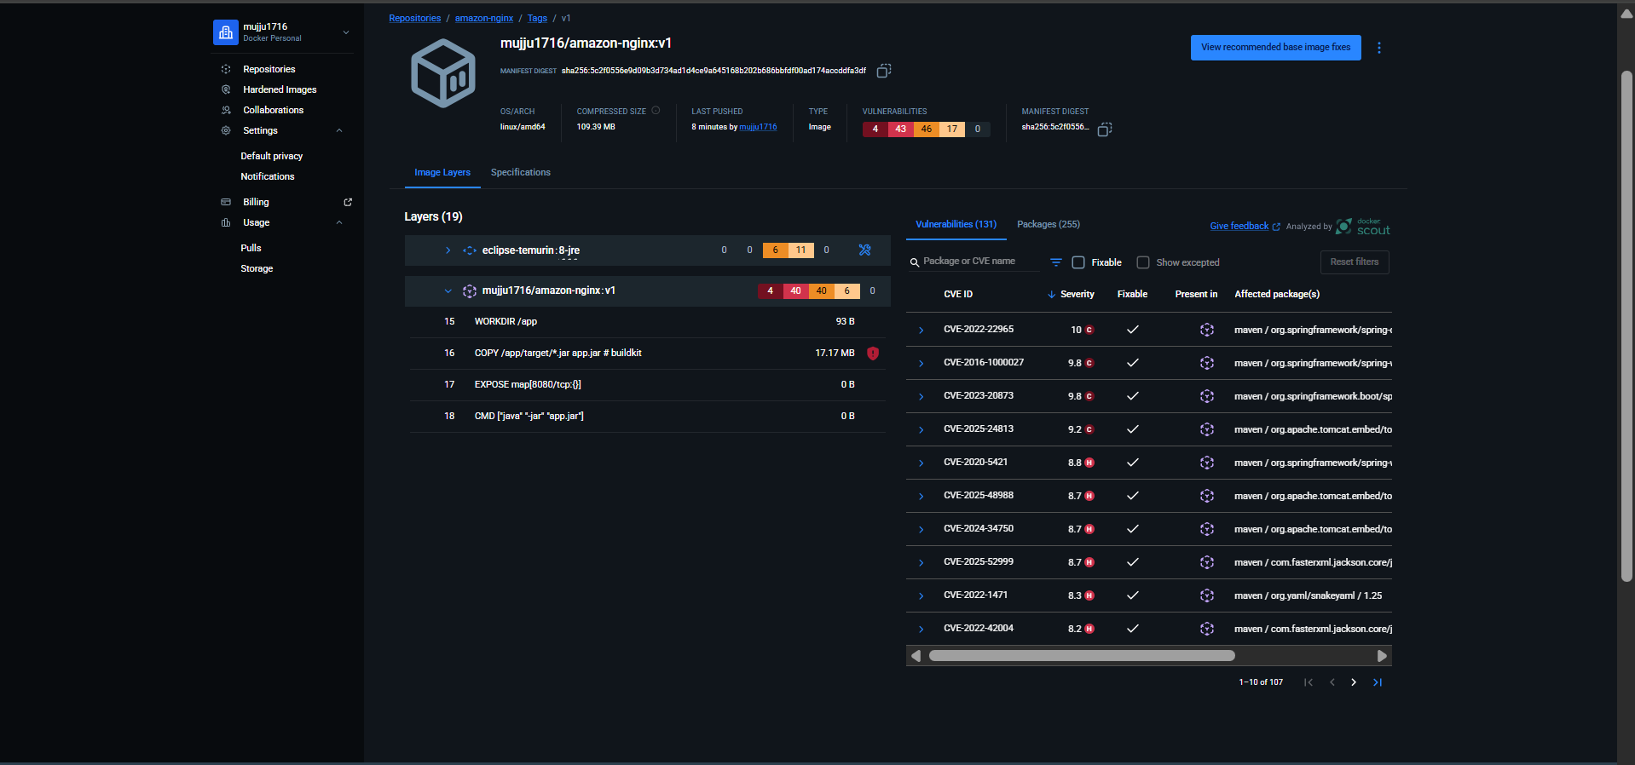

- Implement solution to scan images when pushed to AWS ECR.

authenticated Docker with AWS ECR using AWS CLI.
- aws ecr get-login-password --region eu-north-1 \
| docker login --username AWS --password-stdin 885581373585.dkr.ecr.eu-north-1.amazonaws.com
verified available images.
- docker images
tagged your local image with the ECR repository URI.
- docker tag multi-stage-app:latest \
885581373585.dkr.ecr.eu-north-1.amazonaws.com/amazon-nginx:v1

uploaded the image to AWS ECR.
- docker push 885581373585.dkr.ecr.eu-north-1.amazonaws.com/amazon-nginx:v

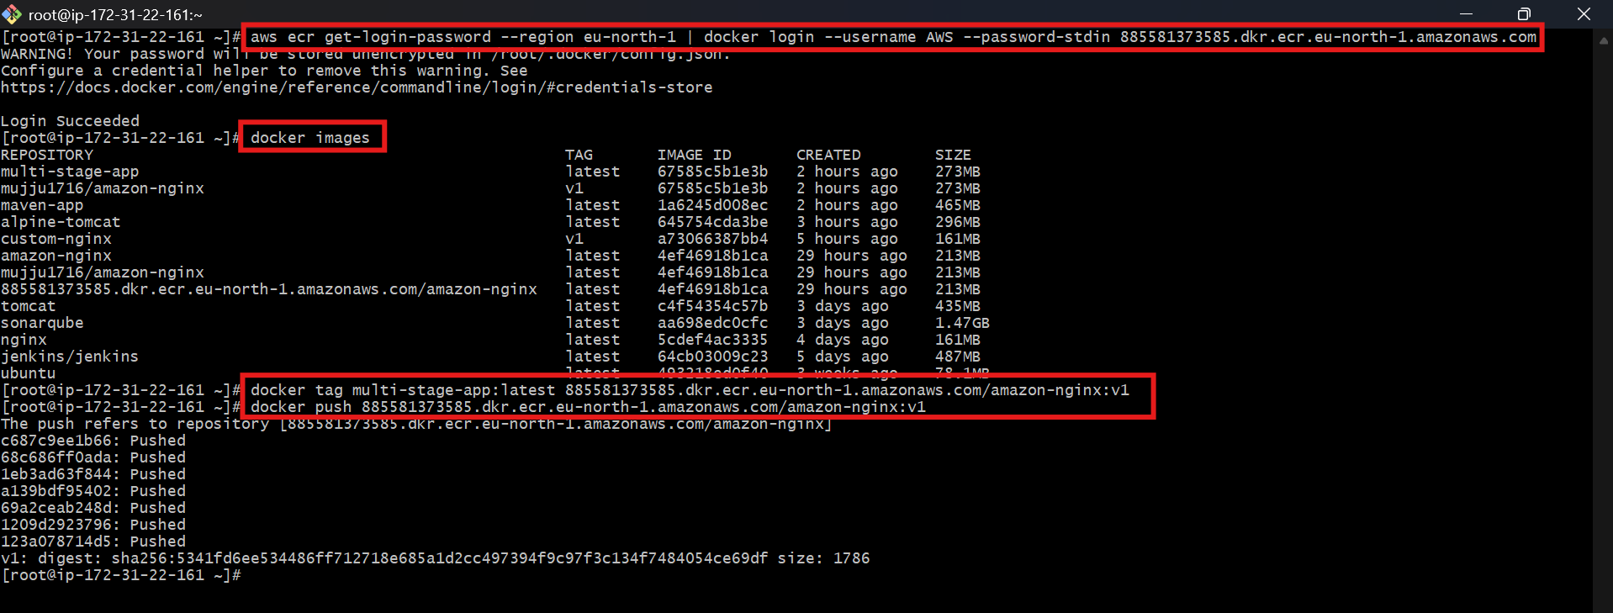
enabled automatic vulnerability scanning.
aws ecr put-image-scanning-configuration \
--repository-name amazon-nginx \
--image-scanning-configuration scanOnPush=true \
--region eu-north-1

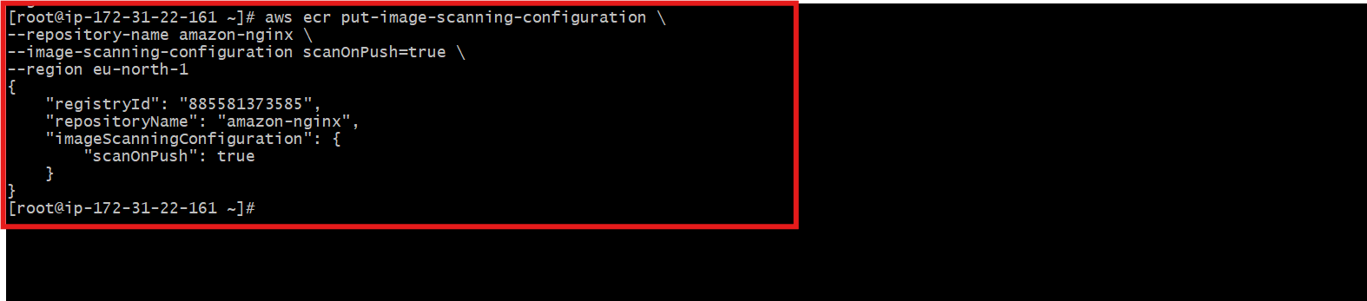
In AWS Console:
ECR → Private registry → Repositories → amazon-nginx → Images

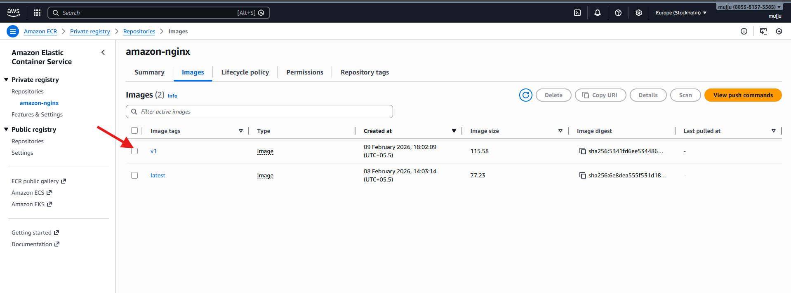
opened the image details and viewed:
Scanning and vulnerabilities → Complete
Critical: 0
High: 0
Medium: 0
Low: 0

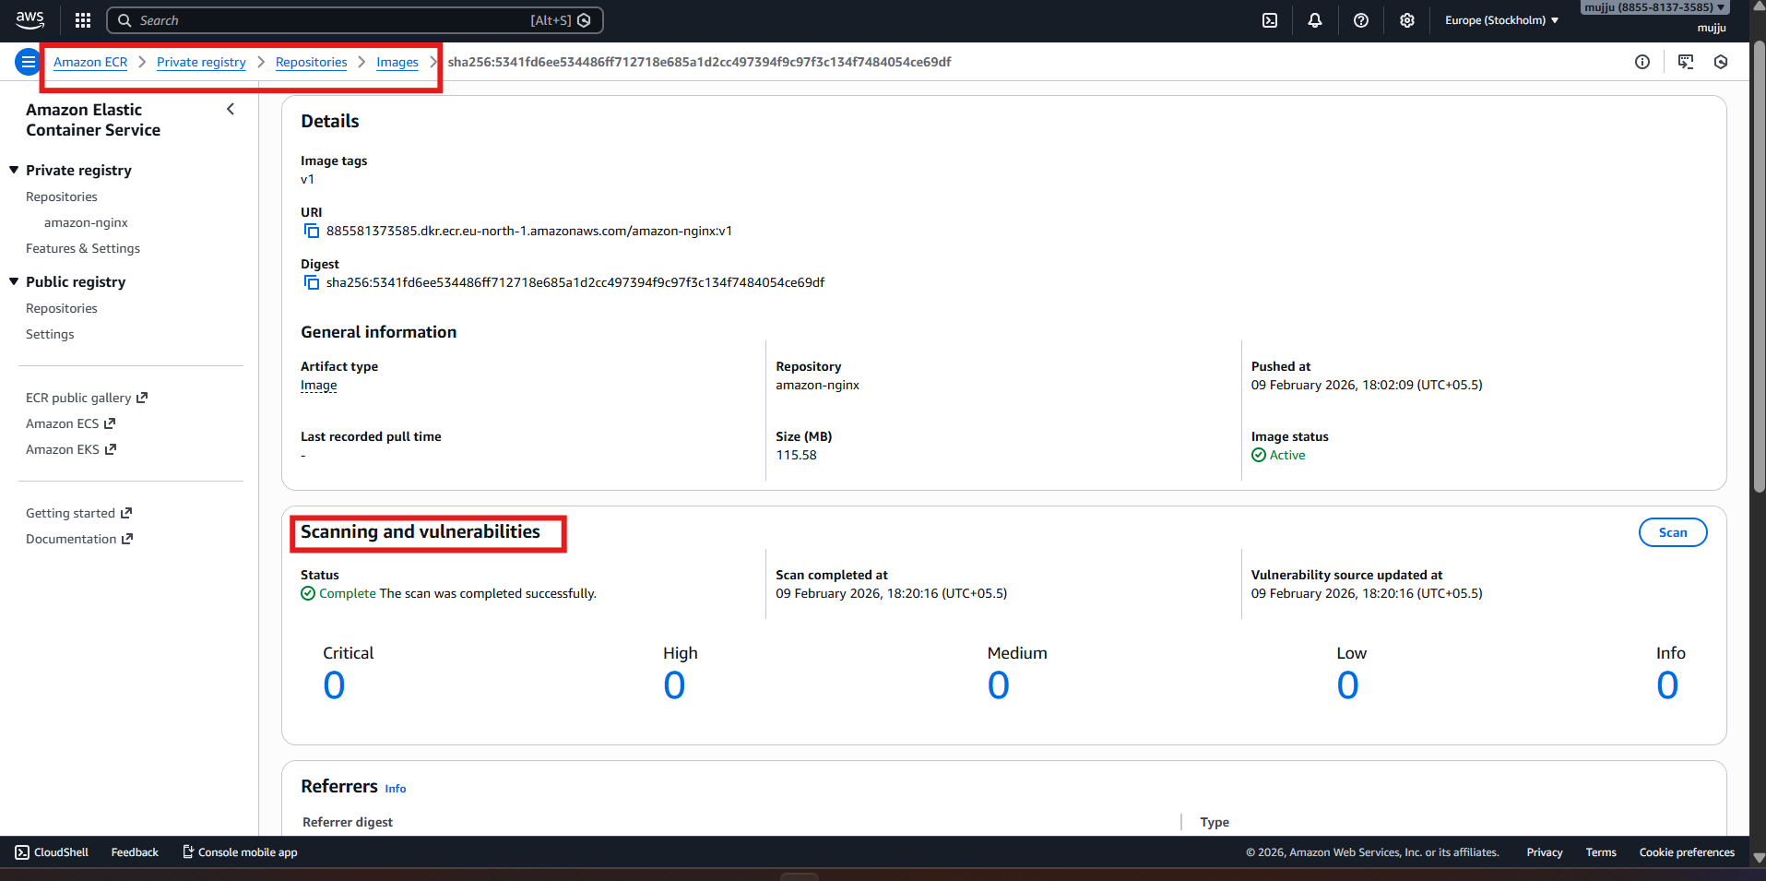

- Create a Jenkins pipeline to create a docker image and push the image to Docker hub.
In Jenkins UI:
- Go to:
- Manage Jenkins → Credentials → System → Global credentials → Add Credentials
- Select:
  - Kind: Username with password
  - Username: muji1716
  - Password: (Docker Hub password / token)
  - ID: Docker
  - Description: Docker
- Click Create
This is used for Docker Hub login in pipelines.

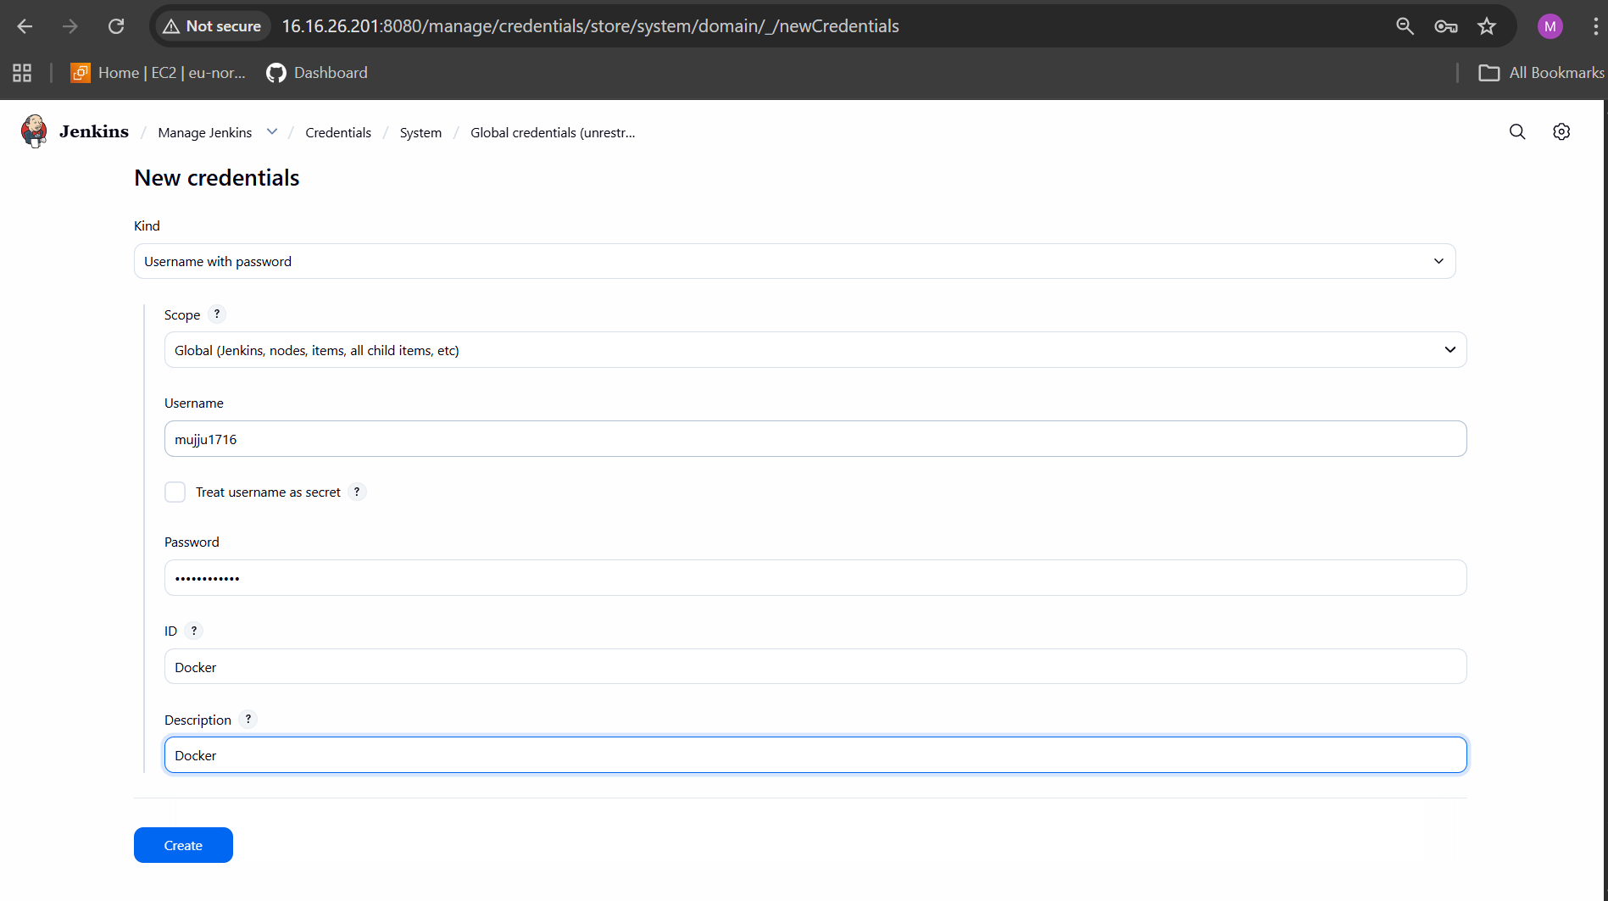

In Jenkins:
Manage Jenkins → Plugins → Available plugins → Search "Docker"
You installed:
✔ Docker
✔ Docker Commons
✔ Docker Pipeline

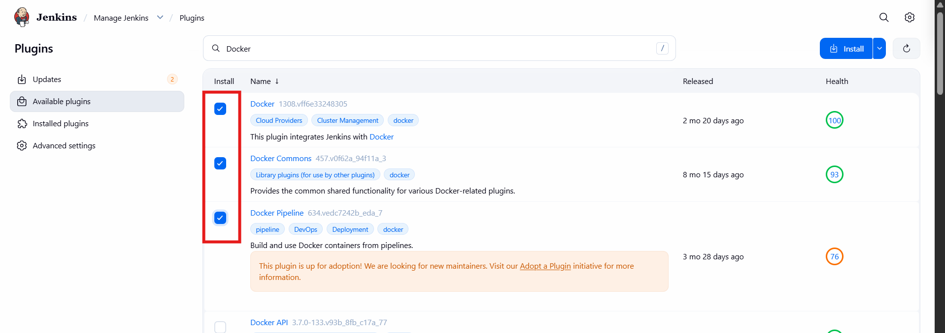
On Jenkins EC2 instance:
- yum install docker -y

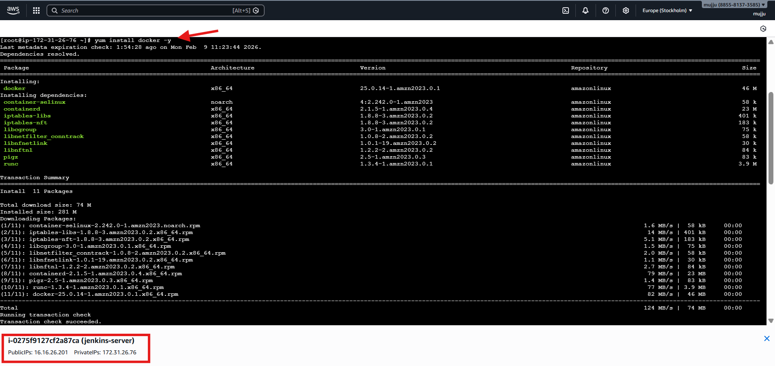
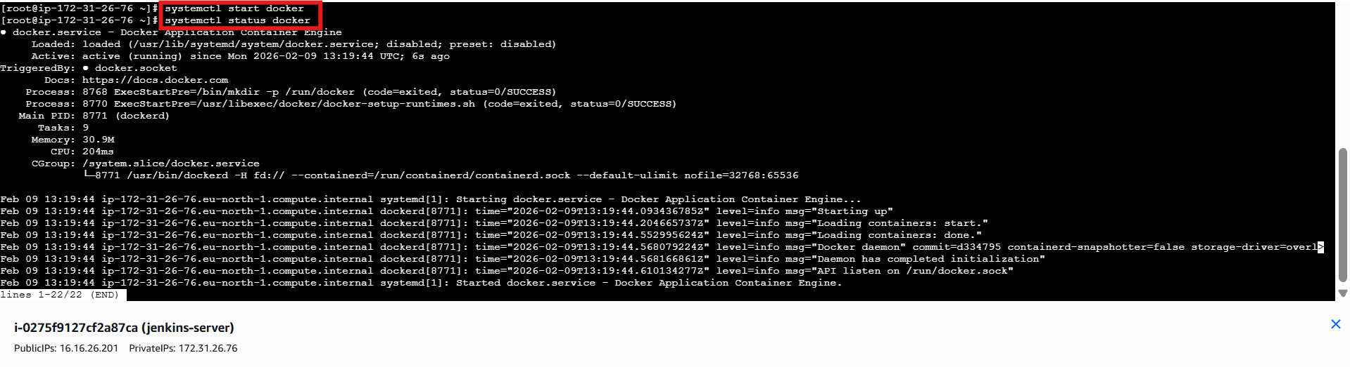
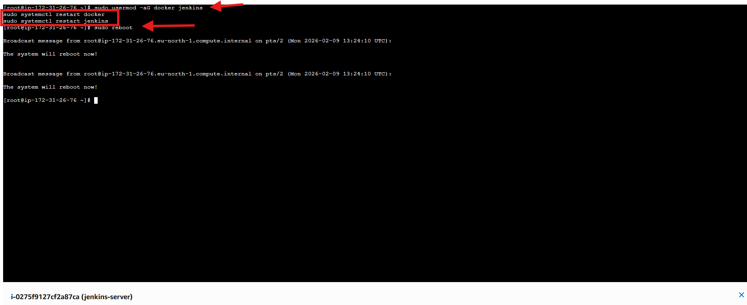
In Jenkins UI:
- Click New Item
- Enter name: Docker
- Select: Pipeline
- Click OK

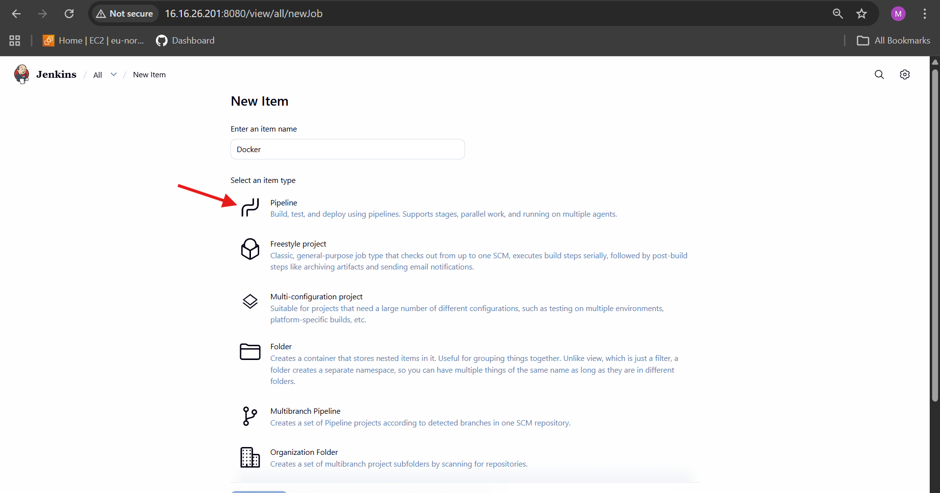
In Job Configuration:
- Definition: Pipeline script from SCM
- SCM: Git
- Repository URL:
- https://github.com/mujahed1716/Docker.git
- Credentials: none / as configured
- Branch: */main
- Click Save

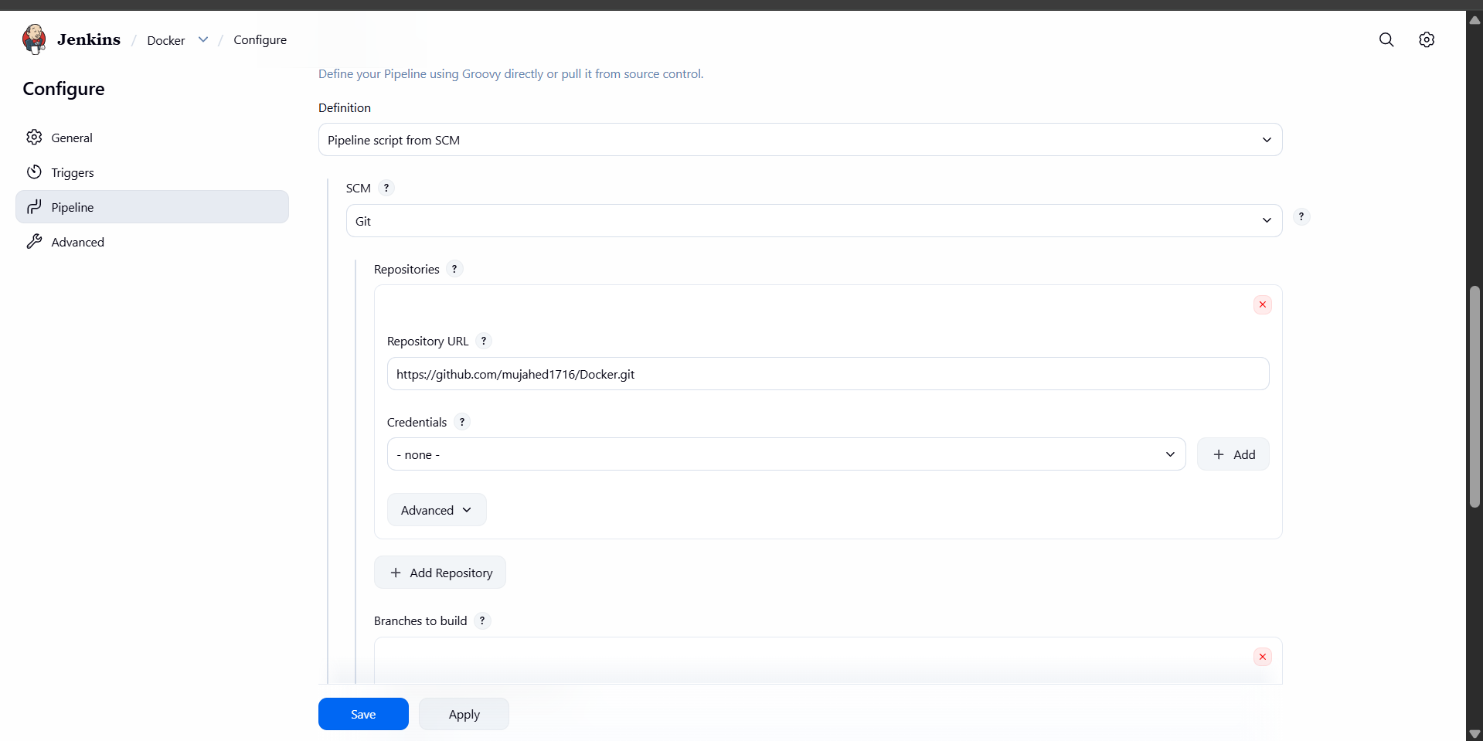
Pipeline Stages Executed
In Stage View, you saw:
1️⃣ Checkout SCM
2️⃣ Checkout Code
3️⃣ Build Docker Image
4️⃣ Docker Hub Login
5️⃣ Push Image to Docker Hub
6️⃣ Post Actions

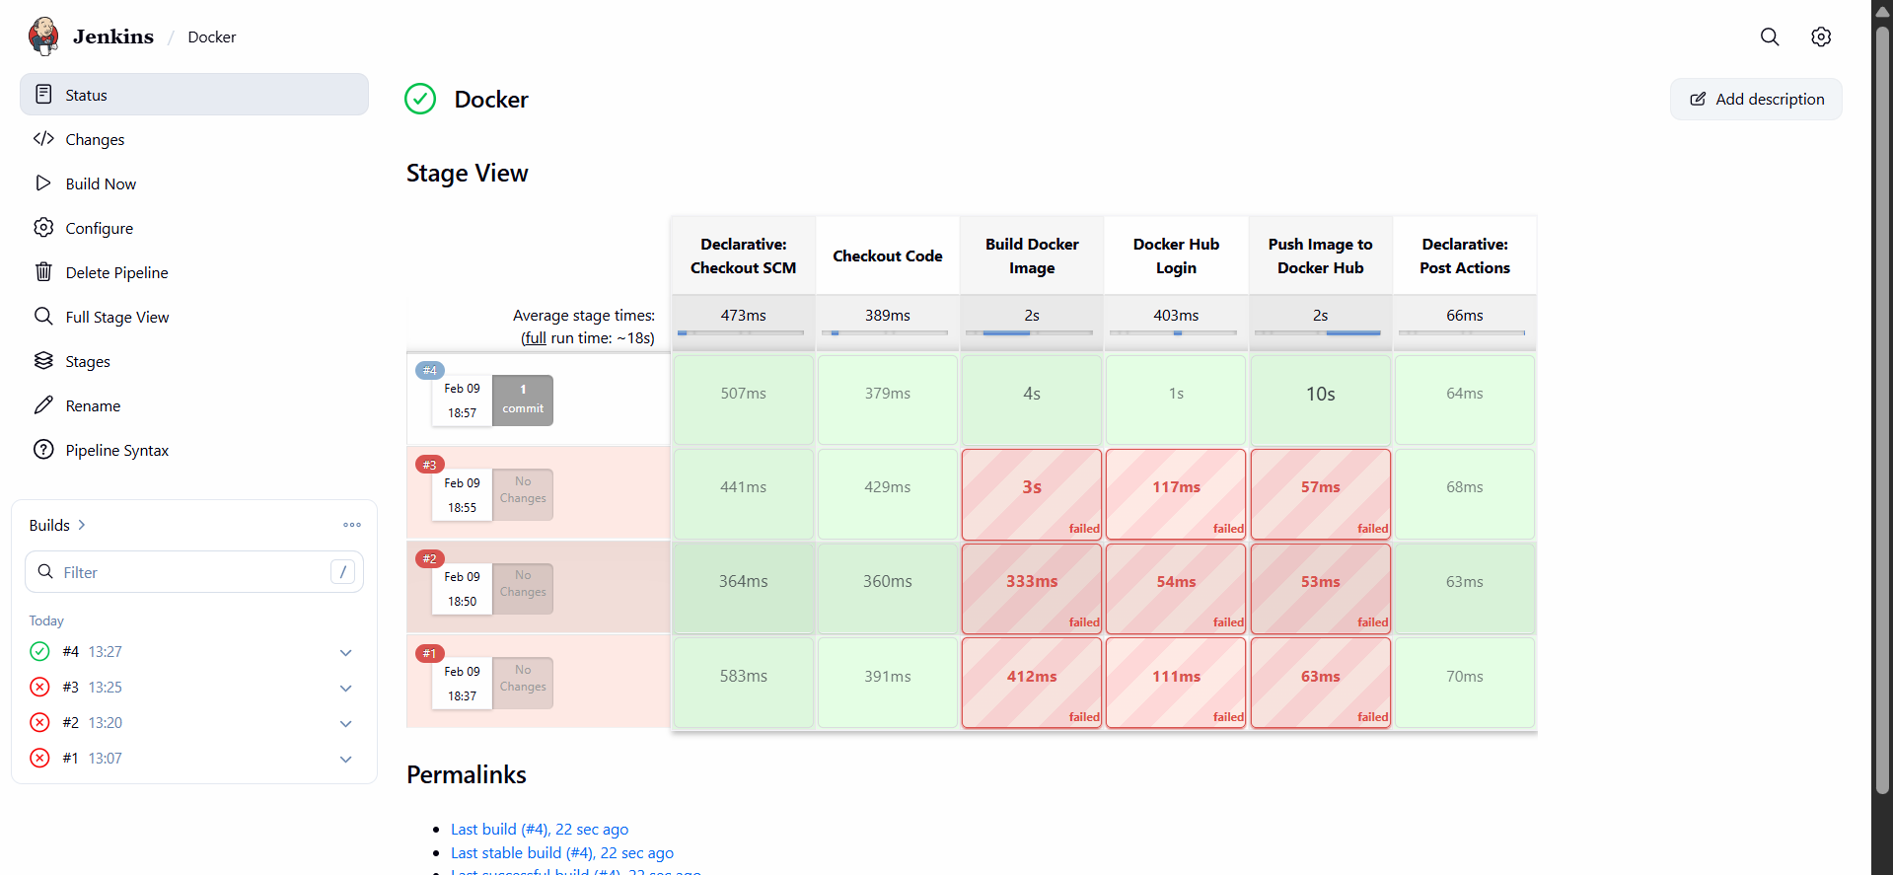

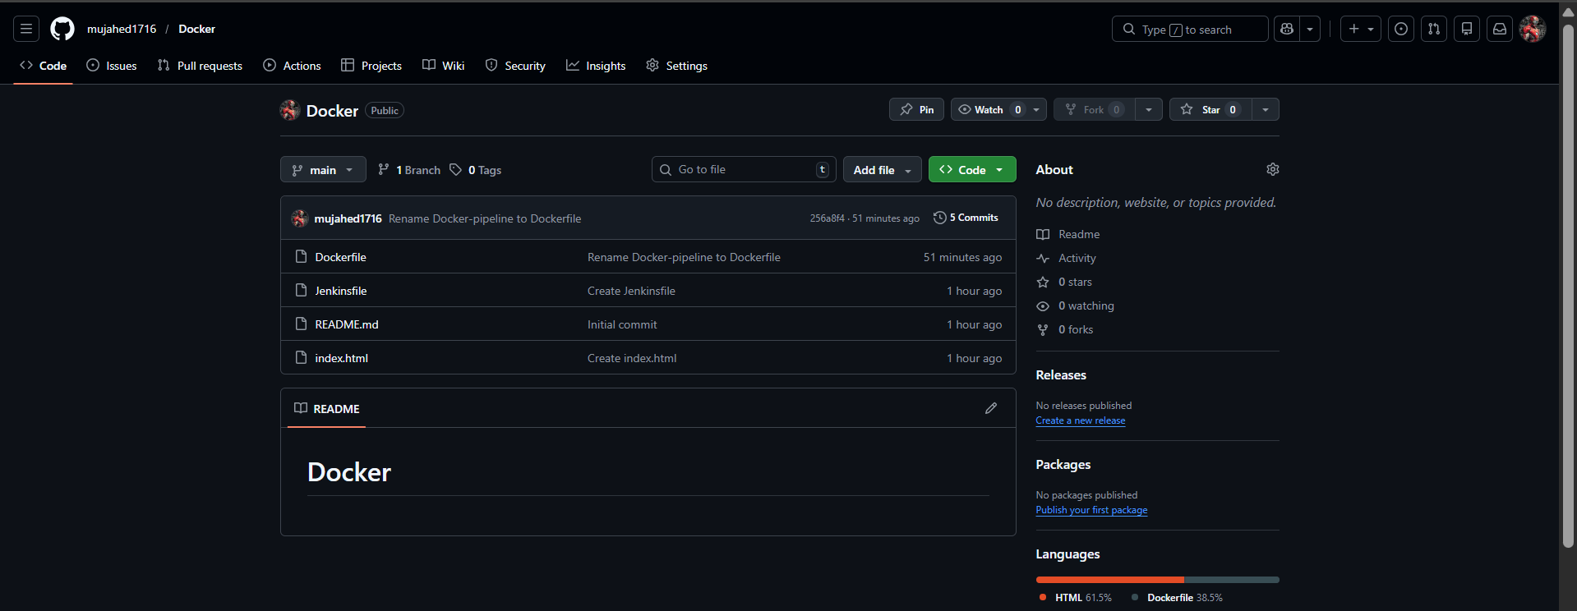

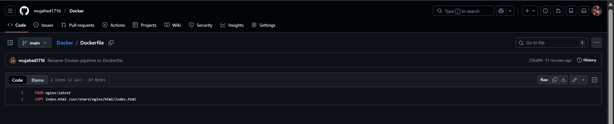
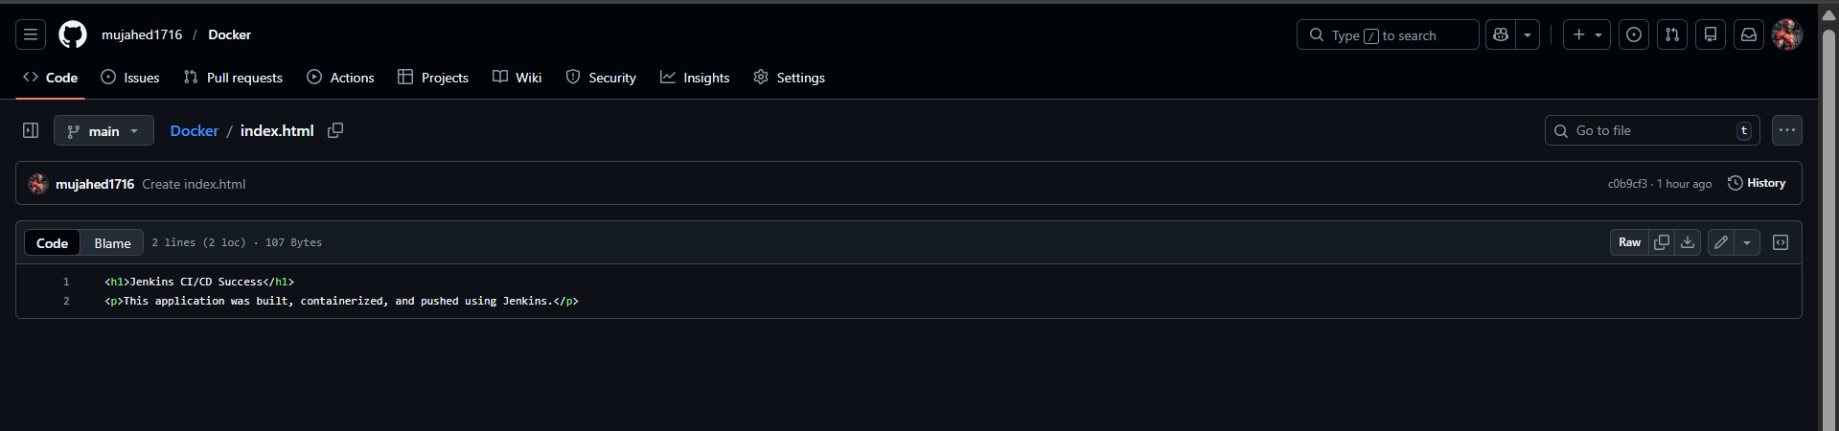
Jenkins file –

pipeline {
agent any

environment {
IMAGE_NAME = "mujju1716/amazon-nginx"
IMAGE_TAG = "v1"
DOCKERHUB_CREDS = "Docker"
}

stages {

stage("Checkout Code") {
steps {
checkout scm
}
}

stage("Build Docker Image") {
steps {
sh "docker build -t ${IMAGE_NAME}:${IMAGE_TAG} ."
}
}

stage("Docker Hub Login") {
steps {
withCredentials([usernamePassword(
credentialsId: DOCKERHUB_CREDS,
usernameVariable: 'DOCKER_USER',
passwordVariable: 'DOCKER_PASS'
)]) {
sh '''
echo "$DOCKER_PASS" | docker login \
-u "$DOCKER_USER" --password-stdin
'''
}
}
}

stage("Push Image to Docker Hub") {
steps {
sh "docker push ${IMAGE_NAME}:${IMAGE_TAG}"
}
}
}

post {
success {
echo "✅ Image successfully pushed to Docker Hub: ${IMAGE_NAME}:${IMAGE_TAG}"
}

failure {
echo "❌ Pipeline failed"
}
}
}

